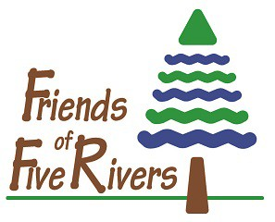

Snow Snake Registration

Winter 2021 into 2022

The following information is required of all Snow Snake Creation and Race participants. If you have any questions or concerns, contact Nancy Conway via email at gsp5rivers@outlook.com.

Adult Lead Participant

Last Name First Name

Mailing Address

City State Zip

Home Phone Work/Cell

E-mail

Choose the best method of contacting you regarding class information or cancellation.
Home Phone Work/Cell Phone Email
Additional Participants

First and Last Name | Age  If Child | Home Phone | Address
1.

2.

3.

4.

5.

Select a Program Date (Circle): December 28 December 29 December 30 February 22

Select a Program Time (Circle): 10:00 a.m. 11:30 a.m. 1:00 p.m. 2:30 p.m.

Select a Race Heat Time on February 24th (Circle): 10:00 a.m. or 1:00 p.m.

Program Fee Includes Materials:
Mail Registration and Fee to:
Friends of Five Rivers
Attention Mrs. Conway
56 Game Farm Road
Delmar, NY 12054

$15 Individual Members; $20 Family Members

$20 Non-Member plus $5 / each additional participant

Friends of Five Rivers – Supporting Environmental Education
56 Game Farm Road, Delmar, NY 12054 · Phone: 518-475-0295 · www.FriendsofFiveRivers.org
Friends is a not-for-profit charitable organization 501c3 · EIN: 23-7309978

