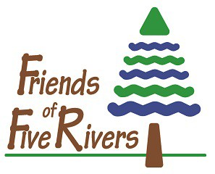

Maple Sugaring at Home Registration

Winter 2022

The following information is required of all Maple Sugaring at Home participants. If you have any questions or concerns, contact Nancy Conway via email at gsp5rivers@outlook.com.

Adult Lead Participant

Last Name First Name

Mailing Address

City State Zip

Home Phone Work/Cell

E-mail

Choose the best method of contacting you regarding class information or cancellation.
Home Phone Work/Cell Phone Email
Additional Participants

First and Last Name | Age  If child | Home Phone | Address
1.

2.

3.

4.

5.

Select a Program Date (Circle): February 7 February 14 February 23

Select a Program Time (Circle): 10:00 a.m. 11:00 a.m. 1:00 p.m. 2:00 p.m. 3:00 p.m.

Program Fee: Includes one spile and reference booklet
Mail Registration and Fee to:
Friends of Five Rivers
Attention Mrs. Conway
56 Game Farm Road
Delmar, NY 12054

$15 Individual Member; $20 Family Members

$20 Non-Members + $5 / each additional participant in pod

Friends of Five Rivers – Supporting Environmental Education
56 Game Farm Road, Delmar, NY 12054 · Phone: 518-475-0295 · www.FriendsofFiveRivers.org
Friends is a not-for-profit charitable organization 501c3 · EIN: 23-7309978

