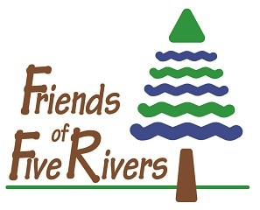
REGISTRATION
FOR
FALL
FAMILY FUN
2021

Parent(s) or

Guardian(s) who will accompany child/children

Last Name First Name

Mailing Address

City State Zip

Home Phone # (_____)___________________ Work/cell # (_____)_____________________

E-mail _______________________________________________________________________ Please indicate month and day. We are offering 2 sessions on both Tuesdays or Wednesdays. Please choose the month(s), the day you are coming and the time you are coming. Please, no switching.
November December
Tuesdays - 2, 9, 16 rain date 23 Tuesdays, 11/30, 12/7, 14 rain date 21
9:30 – 10:30 9:30 – 10:30
10:30 – 12:00 10:30 – 12:00
Wednesdays – 3, 10, 17 rain date 24 Wednesdays, 1, 8, 15 rain date 22
9:30 – 10:30 9:30 – 10:30
10:30 – 12:00 10:30 – 12:00

Child’s Name:_______________________ ________________ Age_____

2nd Child:___________________________________________ Age_____

Fee Information: Members: $8.00 registration per family per month.
$5.00 materials fee per child.

Non-Members: $10.00 registration per family per month.
$ 5.00 materials fee per child.

Registration: $_________ X _____________ = $_____________
# of Months

Materials: $ 5.00 X ______________ X ____________ = +_____________
# of children # of Month
Total Due $_____________
Friends of Five Rivers
c/o Nancy Payne
56 Game Farm Rd
Delmar, NY 12054
Make Check Payable to: Friends of Five Rivers. Mail to:
Friends of Five Rivers – Supporting Environmental Education
56 Game Farm Road, Delmar, NY 12054 · Phone: 518-475-0295 · www.FriendsofFiveRivers.org
Friends is a not-for-profit charitable organization
501c3 · EIN: 23-7309978

